Creating a Chrooted Environment SOP



Table of Contents

1. Creating a Chrooted Environment 3
1.1 Description 3
1.2 Architecture Diagram 3
1.3 Lab Steps 4
1.4 Troubleshooting 5
1.5 Supporting References 5

Creating a Chrooted Environment

Description
A Chroot environment is an operating system call that will change the root location temporarily to a new folder. Typically, the operating system’s conception of the root directory is the actual root located at “”/”. However, with Chroot, you can specify another directory to serve as the top-level directory for the duration of a Chroot. This is an Operating-system-level virtualization and is often used instead of virtual machines to create multiple isolated instances of the host OS.

Architecture Diagram
The diagram below displays a visual representation of the application architecture:
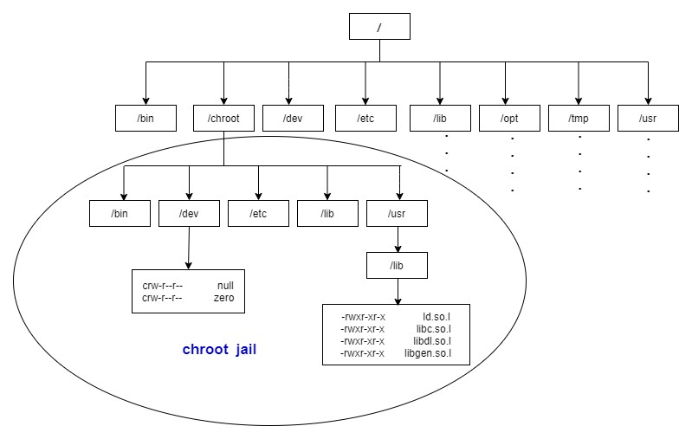

Lab Steps
Follow the steps outlined below to achieve the objective of this lab exercise:

Note: Only a root/privileged user can use the Chroot system call.

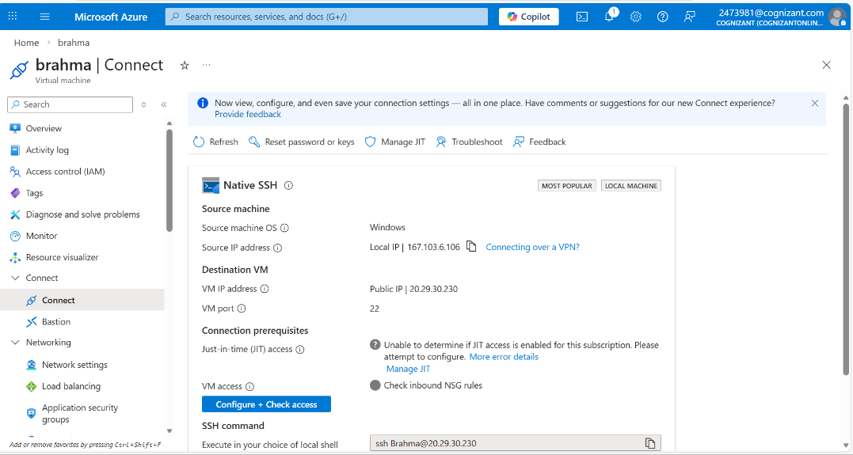
- Create a Linux Virtual Machine and log in to it using public/private key pair:

ssh virtual_machine_name@public_ip_address
sudo mkdir jail
  - jail/
- Create all the essential directories for the command to run.
• Create bin, lib and lib64 directories:
sudo mkdir -p bin lib lib64
- Copy all the files from parent directory to the newly created directories in jail:
  - jail/
sudo cp -rf /bin/* bin/ sudo cp -rf /lib/* lib/ sudo cp -rf /lib64/* lib64/
- Navigate to the directory where you have created jail directory, here in this case, it is present in home.
- Now sudo to Chroot environment using the following command:
  - ~
sudo chroot jail/ bash bash-4.4#
Note: Now you will be popped up with a new shell. Create a test file inside it with the following command:
nano test.sh <write your code> exit
- You can change the permission of newly created file and navigate around in the Chroot environment performing other tasks:
bash-4.4#chmod +x tesh.sh
- Exit the Chroot environment by typing the following command:
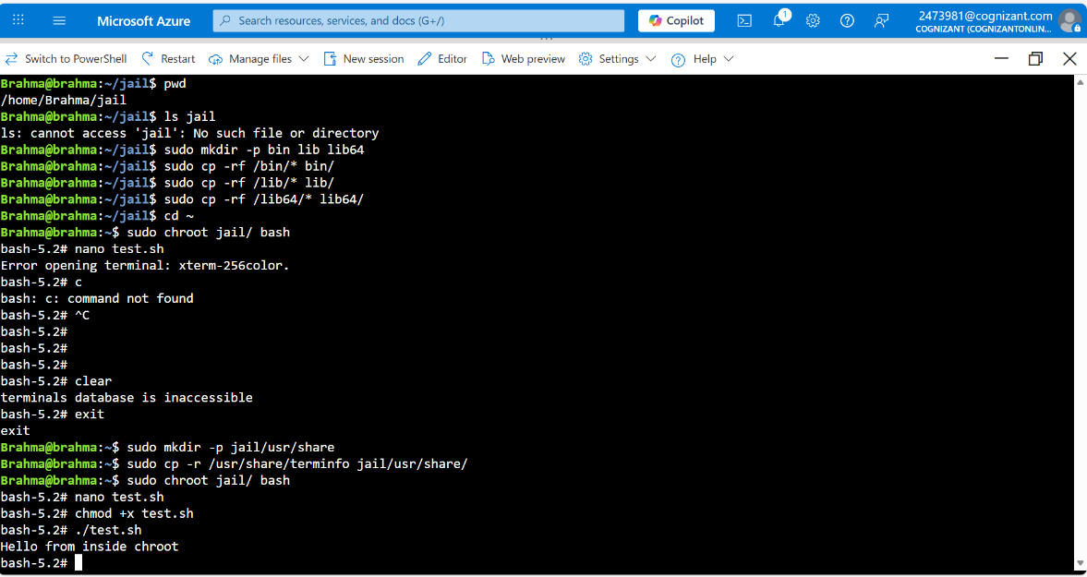
exit Or exit sudo chroot jail

Troubleshooting
S. No | Problem | Solution
1 | Library file not found | Best way is to copy all files from parent directory to the new ones.
2 | Failed to run command /bin/bash | - Either the file does not exist or failed to load libraries  - Recheck if all required files are copied properly in lib and lib64 folder.

Supporting References
Refer the below links for additional information:

- https://www.redhat.com/sysadmin/set-linux-chroot-jails
- https://docs.oracle.com/html/E36387_02/ol_cj_sec.html

